**Name: Sanio Luke Sebastian**

**Roll No: 35**

**Batch: B**

**Date: 02-06-2022**

**NETWORKING & SYSTEM ADMINISTRATION LAB**

**Experiment No.: 13**

**Aim**

To study & know about the network commands within the Linux and Windows OS.

**Procedure**

* **Windows Network Commands**

1. **ipconfig:** This command is used to identify the IP configuration and IP based basic details. Ethernet based information and VirtualBox based IP information are also listed.

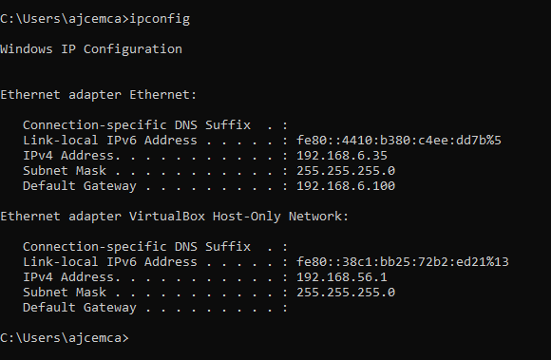

1. **ipconfig /all:** This command is used to introduces more and detailed explanation and connections related to IP configurations and connectivity.

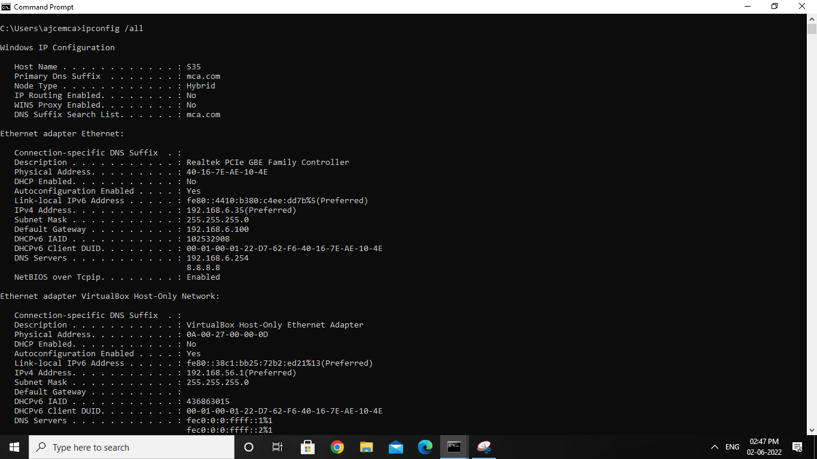

1. **nslookup:** The “nslookup” is used to identify and display the information about your local DNS server and IP address.

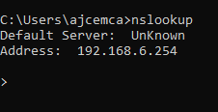

1. **//domain-name:** Within the query terminal which we get using nslookup, by entering a known domain name, we can identify the IP address and the server within the network.

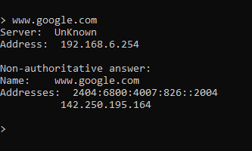

1. **ping //IP-address:** This command is used to send request to a domain/server and it is a primary TCP/IP command used to troubleshoot connectivity, reachability, and name resolution.

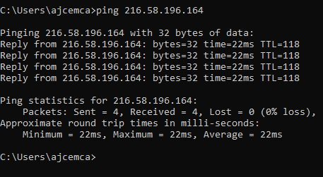

1. **tracert //IP-address:** This command is used for command-line utility to trace the path that an Internet Protocol (IP) packet takes to its destination.

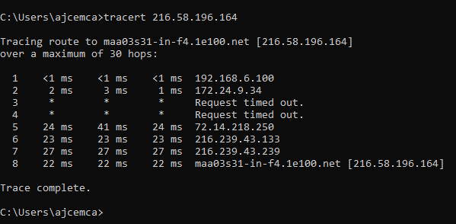

1. **route print:** This command is used to print/display the routing table and connectivity, type of connection used, active routes used and much more related to the route path followed used.

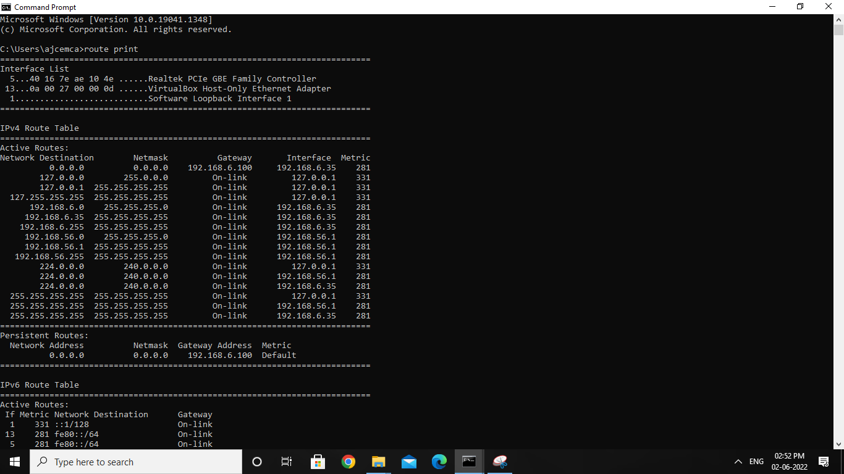

1. **netstat:** This command is used to display the network status and protocol statistics. You can display the status of TCP and UDP endpoints in table format, routing table information, and interface information.

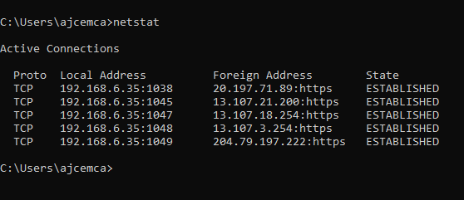

* **Ubuntu Network Commands**

To know about the network commands and connectivity, we are using tcpdump. Tcpdump is a command line utility that allows you to capture and analyse network traffic going through your system. It is often used to help troubleshoot network issues, as well as a security tool. A powerful and versatile tool that includes many options and filters, tcpdump can be used in a variety of cases.

Before the command to run, we have to install the tcpdump into the system. For installation of tcpdump is ubuntu, we know perform the following below command and start with the network commands.

1. **sudo apt update && sudo apt install tcpdump:** This command will update the system required software and install the tcpdump into the system.

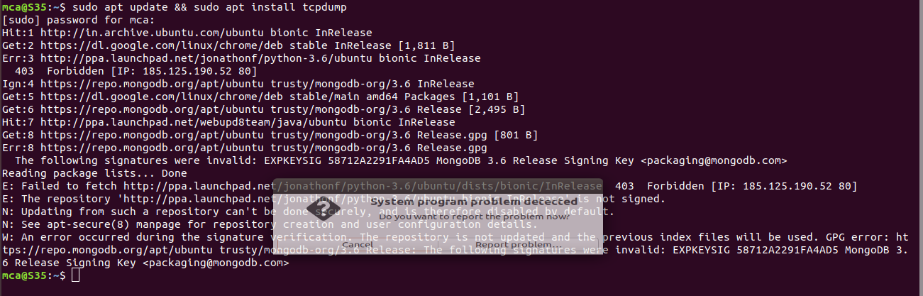

1. **sudo tcpdump:** The command will introduce the running network traffic and inspect them and list it out.

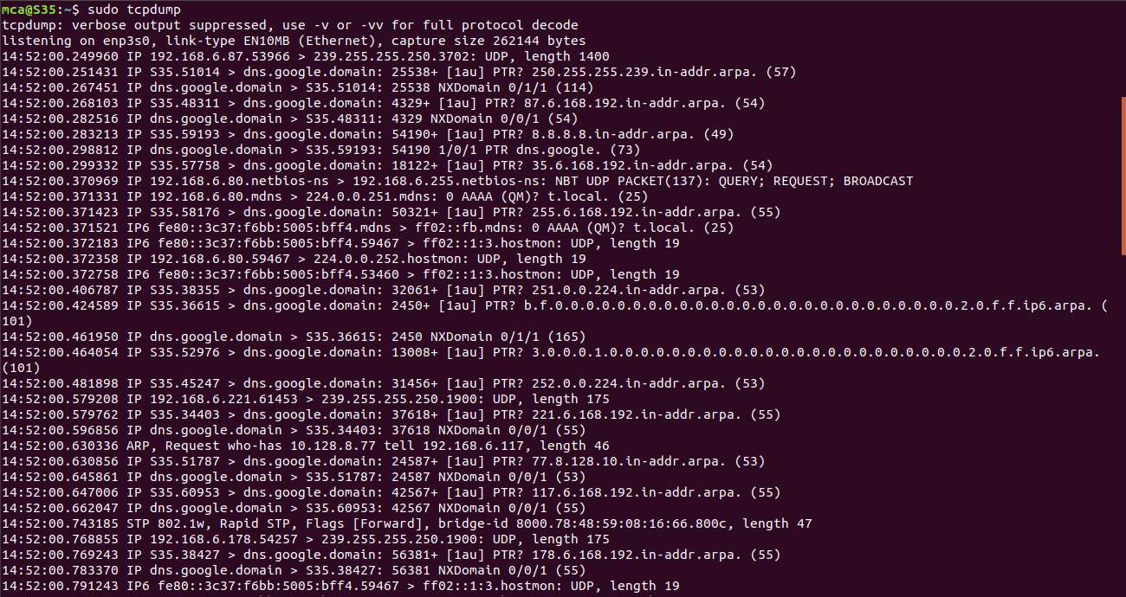

1. **sudo tcpdump -D:** This command will show the running interfaces and -D in the commands helps to capture only the active interfaces currently running the system.

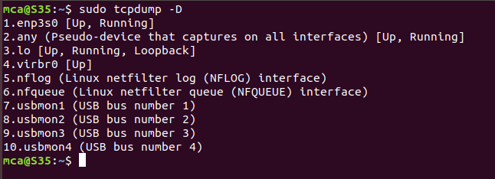

1. **sudo tcpdump -i enp3s0:** This command shows the active network interface called “**enp3s0**” and list the request made via the system through that network.

Here, “-i” indicate that we have to specific only a mentioned interface. And also, here in the “enp3s0”, the “en” stands for ethernet, “p3” is the bus number of the ethernet card, and “s0” is the slot number.

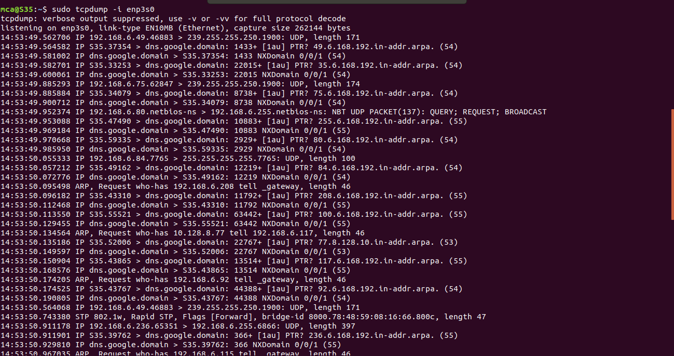

1. **sudo tcpdump -c 4 -i enp3s0:** This command help to list only 4 columns/ lines of traffic in the command line from the specified mentioned interface.

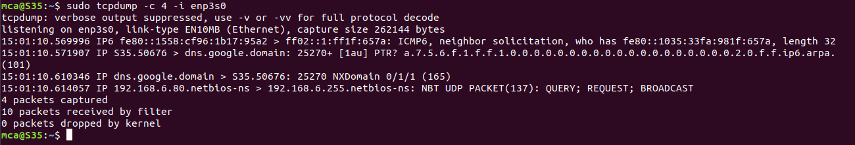

1. **sudo tcpdump -i enp3s0 -c 10 -w icmp.pcap:** This command helps to listen to the traffic from specific mentioned running interface and write those mentioned lines of traffic details to the packet capturing file with extension of “.pcap” with the mentioned name.

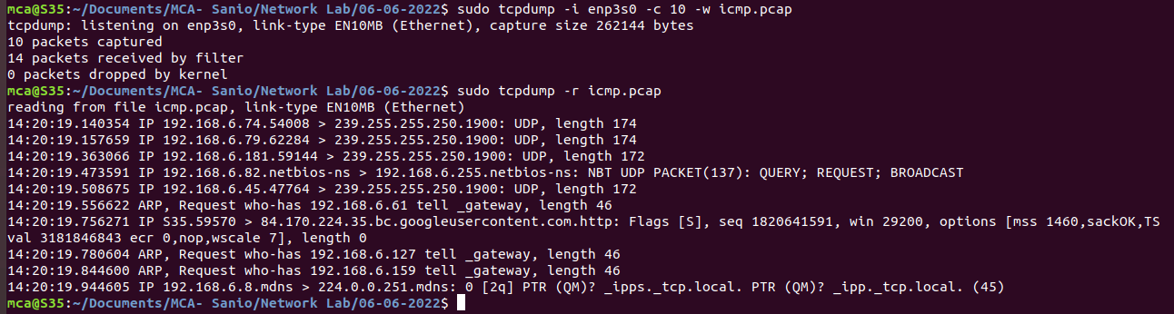

1. **sudo tcpdump -r icmp.pcap:** This command allows us to read from the full-packet capture file (.pcap file) which is mentioned and display it to the terminal.

